SUNKARA SOMESWARI

9550549055

[sunkarasomeswari2003109@gmail.com](mailto:sunkarasomeswari2003109@gmail.com)

21/07/23

**Punith Sir Assignment**

Today’s assignment topic is Method’s in java, let’s go to discuss about that topic.

**Methods in java:**

Methods in java is set of instructions that can be called for execution using the method name (or) methods are the set of instructions used to perform a particular task.

**Syntax of a method:**

return type method name (parameters)

{

//definition

}

**Example:** if a method has to be executed it has to be called by it’s name.

Class demo{

Public static void main(string[]args){

Greet();

Add();

}

Public static void greet(){

System.out.println(“Hello World”);

}

Public static void add(){

int a=10;

int b=20:

int c=a+b;

system.out.println(c);

}

}

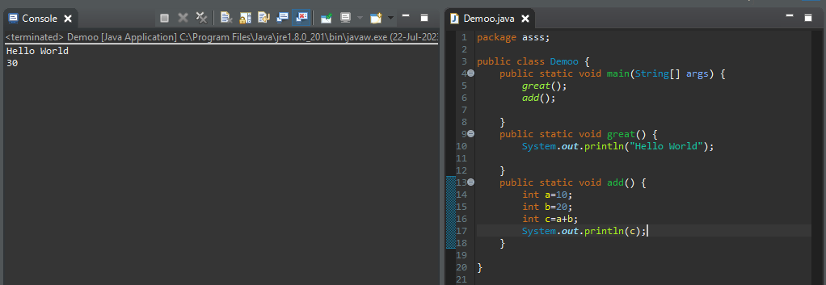

**Conclusion:** in this method we call add and greet for execution of statements or instructions

Based on return type and parameters methods are four types let us discuss one by one with proper example

**Method 1:** no parameters (no input), no return value (no output)

**Method 2:** no parameters, there is an output or return value.

**Method 3:** there is input and no output or return value.

**Method 4:** having both input and output or return value.

Let see one by one in practically.

**Method 1:** method which would not accept any parameters and would not return any value.

**Example :**

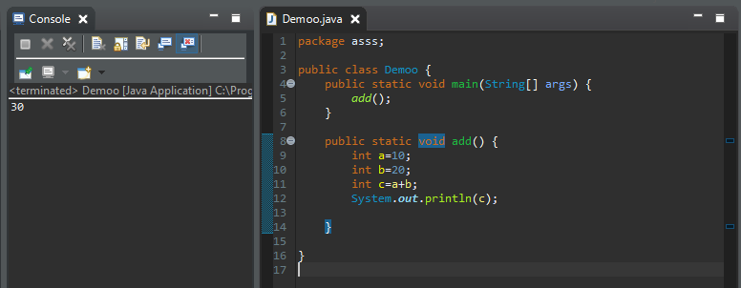

**Conclusion:** in this method there is no parameter is present and would not return any value. We want to return any value without parameters going to method 2.

**Method 2:** which would not accept any parameters and would return a value.

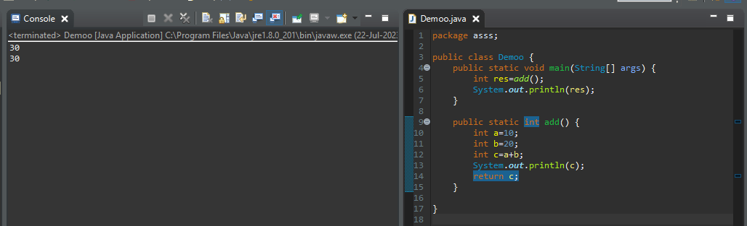

**Method** **3:** which would accept parameters and would not return any value.

**Example :**

Class demo{

Public static void main (string[]args){

int x=10;

int y=20;

add(x,y):

}

Public static void add(int a, int b){

int c=a+b;

system.out.println(c);

}

}

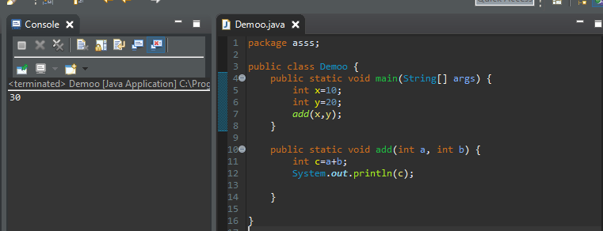

**Method 4:** which would accept parameters and would return value.

**Example :**

Class demo{

public static void main (String[]args){

int x=20;

int y= 30;

int res=add(x,y);

System.out.println(res);

}

Public static int main(int a,int b){

int c=a+b;

return c;

}

}

